In terms of art, line is considered to be a moving dot. It has an endless number of uses in the creation of art.
A simple way of thinking of a line is to imagine a point that moves...
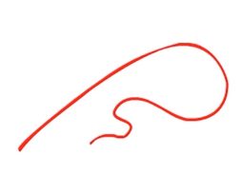
The most common use of line is showing where an object ends. This type of line is called a contour line. Contour lines are most commonly called outlines.
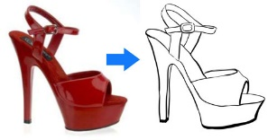
Line can also create the illusion of form in a drawing. Line quality is the thickness or thinness of a line. By varying the line quality an artist can show form in a drawing with just the use of line.
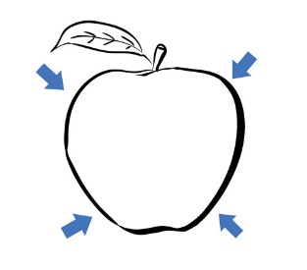Line can also indicate shadow and form through the use of croos contour lines. Cross contour lines follow the contours of the object. Much like running your finger around the form of an object.
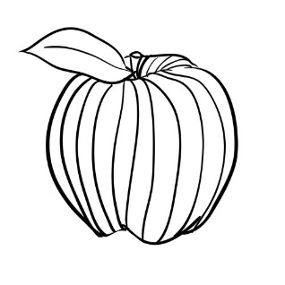

Types of Lines
Vertical lines - lines that move up and down without any slant.
Horizontal lines - lines that are parallel to the horizon
Diagonal lines - lines that slant
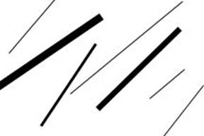
Zigzag lines - lines made from a combination of diagonal lines
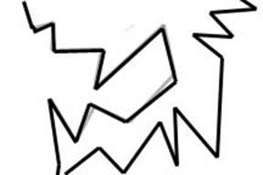
Curved lines - Lines that change direction gradually
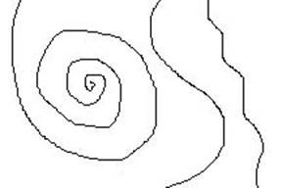
Line Variation - adding interest to your lines is important in creating successful artwork
Length - lines can be long or short
Width - lines can be wide or skinny
Texture - lines can be rough or smooth
Direction - lines can move in any direction
Degree of curve - lines can curve gradually or not at all
Line quality or line weight - refers to the thickness or thinness of a line. By varying the line quality artists can make objects appear more 3-Deminsional and more interesting

Hatching – lines going in the same direction
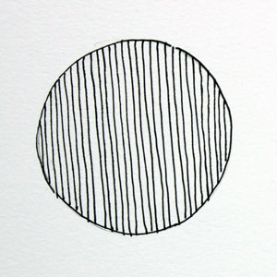

Cross Hatching – lines that cross

